Manuscript format (Times New Roman Bold 14pt)
―For papers written in Japanese (Times New Roman Bold 14pt)―

Taro Ningen¹, Hanako Seikatsu², and Jiro Bunka¹

¹Institute of Human Culture Studies, Otsuma Women’s University (Times New Roman 10pt)
12 Sanban-cho, Chiyoda-ku, Tokyo, 102-8357 Japan
²Faculty of Human Studies, Seikatsu Bunka University
8 Goban-cho, Chiyoda-ku, Tokyo, 102-0000 Japan

Key words：Human, Life, Culture, Global society (Times New Roman 10.5pt)

Abstract
(Times New Roman 10.5pt [200 words limit]) The International Journal of Human Culture Studies is the online journal for the Institute of Human Living Science at Otsuma Women’s University, a research center with over 30 years of history. The journal is seeking research manuscripts dealing with various aspects of human living and culture. Submissions may cover a broad range of fields, including: human life science, literature, sociology, psychology, education, informatics, environmental science, anthropology, agriculture, physics, chemistry, biology, and others. The journal welcomes authors of all backgrounds, in various languages, and submissions are free of charge. Manuscripts are published promptly after passing editorial and/or peer review. The journal uses J-STAGE (Japan Science & Technology Information Aggregator, Electronic), and links with international electronic journals and other sites, to allow your paper to be read by a worldwide audience.

1. Manuscript Type and Content (Times New Roman Bold 10.5pt)
(Times New Roman 10.5pt) We welcome all original manuscripts, brief communications, review articles, reports, materials/data, book reviews, and letters to the editor. Please select the type of manuscript when submitting.
Manuscripts should not have been previously published in any journal or other citable form.
There is no word limit for manuscripts.

2. Manuscript Preparation
2.1. Manuscript File Format
We accept only Microsoft Office Word documents (.docx files). Please use A4 page size, with 2 columns and 45 lines per page. For other formatting, please use the same settings as this document template.

2.2. Languages
Peer-review articles (original papers, brief communications): Japanese or English.
Non-peer-review manuscripts (review articles, reports, materials/data, book reviews, letters to the editor) can be submitted in any language. However, in addition to the original language, please also include the following items in English: title, subtitle, author name, names of affiliated organizations, abstract, and keywords.

2.3. Units of Measurement
We conform with the International System of Units (SI).

2.4. Structure of Manuscripts
(1) Title, Subtitle
If the manuscript is not in English, please submit the title and subtitle in both the original language and in English.

(2) Authors
Please list the full name of the authors. If the manuscript is not in English, please list the full name in both the original language and in English. In the case of multiple authors, please list in the order of greatest contribution to the research or writing of the manuscript. Authors are limited to 20 people.
Do not include academic degrees or other titles.

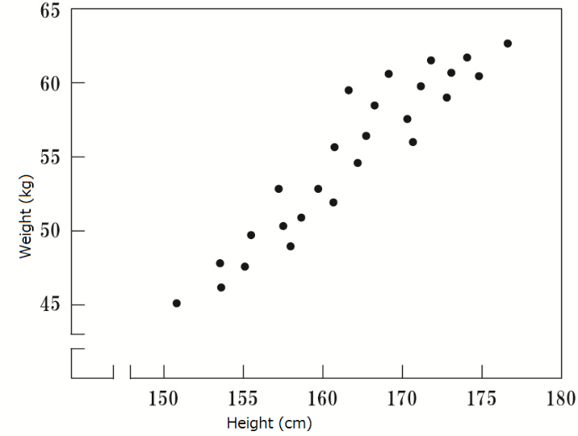
Fig.1 Diagram Caption
(Times New Roman Bold 10pt)
*There are no specific requirements regarding font type or font size used in figures.

(3) Names of Affiliated Organizations
Please submit the names of affiliated organizations in both the native language and in English. Do not include the address of organizations. In the case of multiple authors, use numbers or symbols to clearly indicate which author belongs to which organization.
In the case of a single author, do not include numbering.

(4) Abstract
If the manuscript is not in English, please include an abstract in English as well in the original language.
Please limit your abstract to maximum 200 words (English) or 1,000 characters (Japanese).

(5) Keywords
If the manuscript is not in English, please provide 3-5 keywords in both the original language and in English.

(6) Manuscript Body
Charts and illustrations may be inserted into the body of the manuscript.
Citations made within the body of the manuscript should use the following format:
example 1) According to Sato ^{[1]}...
example 2) ...has made similar findings. ^{[2]}

Table 1 Chart Caption
(Times New Roman Bold 10pt)
High school  grade | Boys | Girls | Total
1 | 615 | 509 | 1124
2 | 510 | 350 | 860
3 | 482 | 370 | 852
Total | 1607 | 1229 | 2836
*There are no specific requirements regarding font type or font size used in figures.

3. Selection of Referees
Please recommend 3-5 referees for your manuscript when submitting peer-review articles (original manuscripts, short communications). Your recommendations will be considered when assigning referees. Please do not recommend anyone with a conflict of interest, such as members of your own institution; they will not be selected as a referee.

4. How to Submit
We accept submissions on-line. Please go to this publication’s home page. (https://journal.otsuma.ac.jp/)

Acknowledgments
Under the heading of “Acknowledgments”, you may mention the people and organizations that supported you during your research. Along with their names, you may briefly describe in what way they assisted your work. Please write acknowledgments when you submit your manuscript.

Sources
Please list the sources you cited at the end of your manuscript, in the order of citation and with corresponding numbers (e.g. [1],[2],[3]...) For multiple-author sources, list the first author, followed by “et al”.
Please use the same writing style for information sources in the list.

*Example of description
<Journals>
Author name. Title of article. Title of journal. Publication year, volume number, first page - last page.

Example: Ohsawa, Seiji et al. Growth standards for children's weight of 12 ethnic groups in Myanmar and Thailand. Japan Journal of Human Growth and Development Research. 2011, 51, p.46-56.

<Books>
Author name. “Title”. Editor name. Name of book. Publisher, publication year, first page - last page.

Example: Harrison, Bruce. “Risks of handling cytotoxic drugs”. The Chemotherapy Source Book. 3rd ed., Lippincott Williams & Wilkins, 2001, p.566-580.

<Website>
Author name. “Web page name”. Website name. Web address, (date of access).

Example: “Grants.gov Application Guide SF424 (R&R)”. U.S. Department of Health and Human Services.
http://grants.nih.gov/grants/funding/424/index.htm, (accessed 2012-2-1).

<Patents>
Patent applicant name. Patent name. Patent number. Date of patent.

Example: Arata, Andrew. Process for treating water. U. S. Patent 6890953. 2005-5-10.

Abstract (Japanese)
(MS Mincho 10.5pt [Alphanumeric characters: Times New Roman] 1000 characters limit) If possible, please include an abstract in Japanese here. If not, please delete this section.

Key words (Japanese)：(MS Mincho 10.5pt [Alphanumeric characters: Times New Roman]) If possible, please include keywords in Japanese here. If not, please delete this section.

ID Photo

Photo Size Guidelines

Height: 2.5cm
Width: 2.0cm
Taro Ningen (Times New Roman Bold 10.5pt)
Present post:
Researcher, Institute of Human Culture Studies, Otsuma Women’s University (Times New Roman 10.5pt）

Profile：（Times New Roman 10.5pt）Please include your CV here.
Graduated from the Department of ○○, Faculty of ○○, ○○ University (Degree: ○○).
Specialized in ○○ Studies.
Editorial Board Member, Journal of ○○○○ Society (20XX-present).
Visiting Research Fellow, ○○○○ Association (20XX-present); Board Member, ○○○○ Society (20XX-present).
Born in ○○ Prefecture in 19XX. After completing the Graduate School of ○○ University, worked at ○○○○ before joining ○○ University.
Since the 19XXs, has been engaged in research on ○○○○ of ○○, and is currently conducting joint field studies with ○○.

Major publications:
<Books>
Author name. Book title. Publisher, Publication year, total pages (e.g., 152 p).
Author name. Book title. Publisher, Publication year, total pages.
<Journals>
Author name. “Article title.” Journal name. volume number (issue number), Publication year, first page-last page.
Author name. “Article title.” Journal name. volume number (issue number), Publication year, first page-last page.

*In the case of multiple authors, only the first author listed will be featured in the ‘About the Author’ section.
*The first author must clearly state their institutional affiliation and professional title to clarify their academic and professional responsibility, specifying their academic background, field of specialization, main achievements, and academic degree to indicate their research background.
If the first author does not belong to any affiliated organization or research institution, they must clearly state, in this section under “Author Information,” their professional background — including previous positions, research or teaching experience, and relevant professional practice — using appropriate designations (e.g., “Former Professor at XX University,” “Teacher at XX High School,” “Representative, XX Research Group”).

